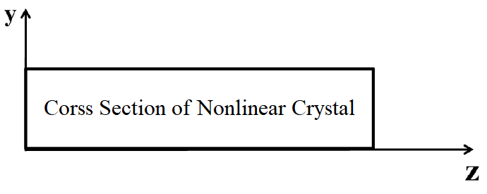

T = cte

Convection

&

Radiation

Convection

&

Radiation

Insulation